PARISH NEWS
The Deverills & Crockerton
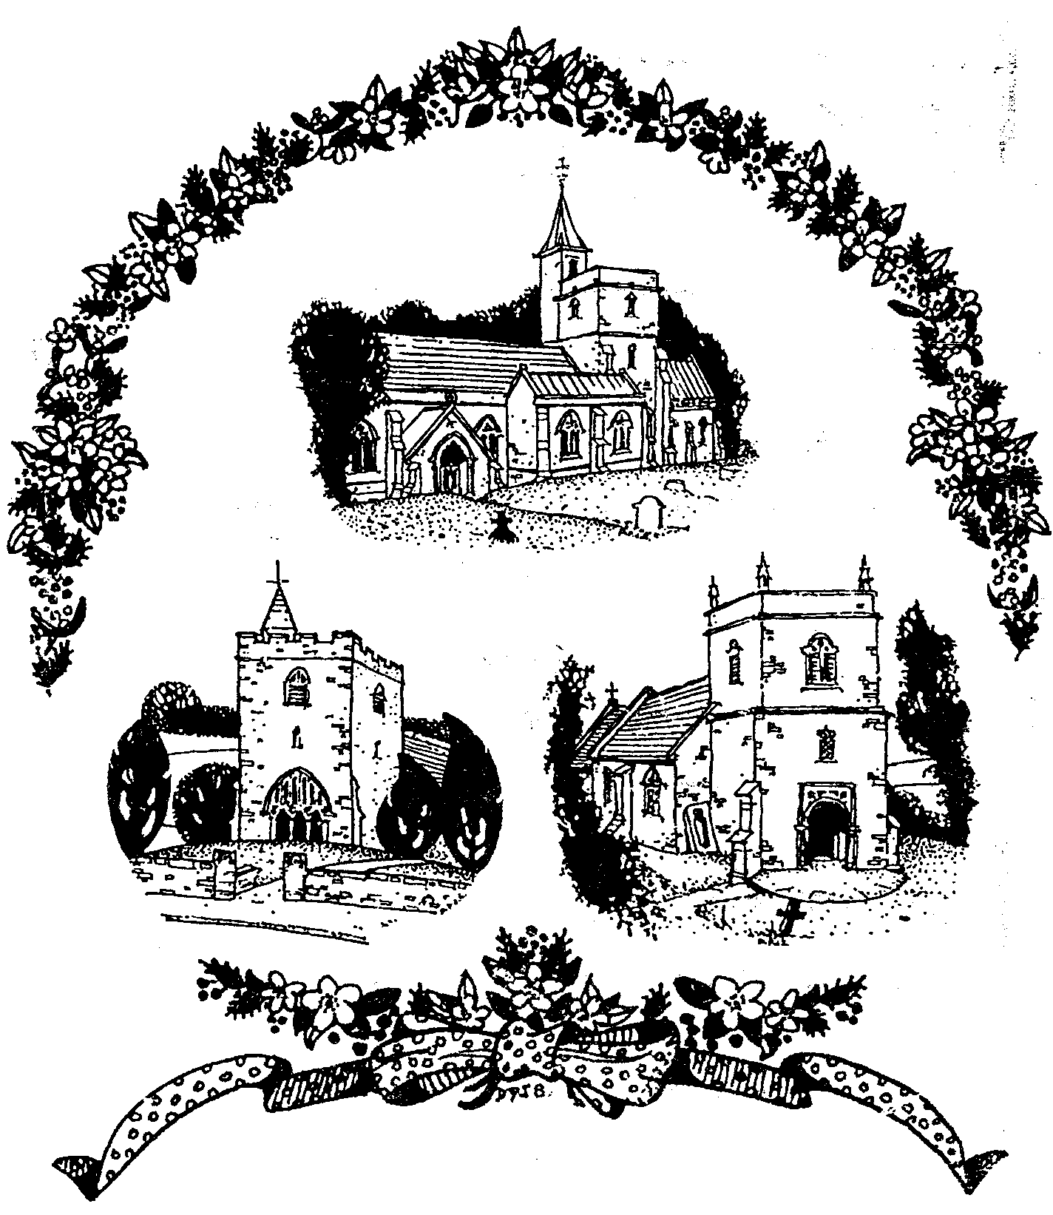

Our Three Churches
by Dennis Smith

December 2008

Look inside for local information

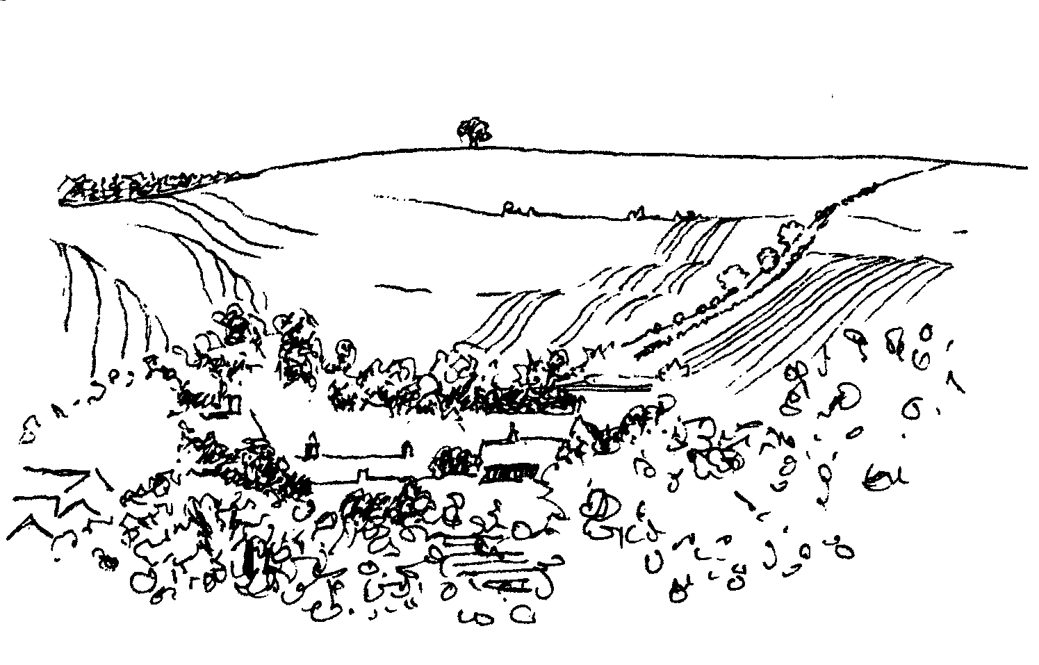
-2-

Crockerton School Christmas Bazaar

Friday 5th December 6.00 - 7.30 pm

Everyone is welcome to join us for Christmas fun & activities: Card Making, Chocolate Tombola, Jolly Socks
Santa’s Grotto! Delicious Refreshments

CROCKERTON VILLAGE COMMITTEE & CROCKERTON SCHOOL
Children’s Carol Service Procession Tuesday 9th December 6.00 pm
Starting at Broadmead Lane progressing to Bath Arms Crockerton
A grand switch on of the Christmas Tree lights
And a blessing of the tree by our Rector Norma Payne
Carols, mulled wine and mince pies
Everyone is Welcome
Please bring a Christmas decoration or bird food for the tree

Thursday Group - Pre-school & Parents
Open Morning at Longbridge Village Hall
Thursday 11th December
You are invited to join us for
hot drinks, mince pies and sausage rolls

NB: The Group will be closed for Christmas Holidays on 18th December and will reopen on 15th January 2009 from 10.00 to 11.30am

Longbridge Deverill Village Hall
COMMUNITY CAROL SINGING
Saturday 13th December at 5.00 pm
Mince pies, sausage rolls and punch to help your voices
Come and join in our Christmas festivities
MERRY CHRISTMAS & HAPPY NEW YEAR
BURNS NIGHT SATURDAY 24TH JANUARY
More information from Sylvia Titt 214825 / Pat Wood 840535

-3-

Christmas is coming ……
How is it that the old rhyme goes?
Christmas is coming, the geese are getting fat;
please put a penny in the old man’s hat.
If you haven’t got penny, a ha’penny will do;
if you haven’t got a ha’penny, then God bless you!
With decorations and cards, crackers and gifts in the shops for months now, all of us have been aware of the ‘countdown to Christmas’, even if we have been determined not to get caught up in it. I suspect that for many people this year some adjustment might need to be made to original plans and expectations. While there is sympathy for such situations, our physical circumstances do not have to diminish our enjoyment and celebration. After all, Christmas is the time we celebrate and remember the greatest gift of all – the birth of God’s son.
Joseph and Mary might have wished their circumstances to be different. However, news of what happened to them on that first Christmas night spread far and wide, and has changed lives for ever. Maybe a little ‘re-thinking’ on our part will have the capacity to change our lives too.
In these days of Advent, we take time to prepare to receive the Christ-child. As we get ready to welcome his coming, it is good to step aside from the hurly burly. It is good to find cause to pause, to be quiet and reflect on our preparedness to hear again this wondrous story.
In the midst of our busy-ness, it is right to remember those who have little to celebrate and, as a result, to be generous with our time, with our money, and particularly with our company especially to people who will be alone, unable to celebrate with family or friends.
May God be with you through this Advent season, and bless your celebrations of the best present of all!
Norma Payne - Rector
Cause to Pause ~ Calm before Christmas
Advent Bible Study at The Rectory, Longbridge Deverill
7.30 - 9.00 pm on 3rd, 10th and 17th December. ALL WELCOME

Quiet Morning at St. Margaret’s, Corsley 10.00 - 12.00 noon
Tuesday 16th December ~ A time of quiet, music and reflection for Advent
Dr Elloway in the D R of Congo
Francesca returned to Aru recently as her Bishop Ande considered it was safe. Francesca has emailed to say all is well as the problems in Goma and Bunia are 7 days travel away. She asks us to pray for the problems to be resolved and peace to return. UNICEF is appealing for funds for the hungry and displaced. A great problem is communication, with poor roads and few airfields to bring in supplies. She also asks us to pray for her work, for help with administration and accounts, giving her more time for medical work, teaching and learning how to use the ultrasound machine she took back with her. There is a copy of her letter in each church.
Elisabeth Atkinson

-4-

Deverill Valley & Crockerton Women's Institute
Longbridge Deverill Hall
Monday 8th December 7.30 pm
Christmas Dinner
The George, Longbridge Deverill
For more information contact Ann Dufosee 840360


The Athenaeum Singers
Registered Charity No 290909
A Concert of Christmas Music
A Ceremony of Carols - Benjamin Britten, In Terra Pax - Gerald Finzi
The Winter Journey - Alan Bush, Songs of Christmas - Paul Carr
and Traditional Carols for All
International Soloists, Bath Philharmonia - Gavin Carr - Conductor
Saturday 20th December at 7.30pm

THE MINSTER CHURCH OF ST DENYS, WARMINSTER
(by kind permission of the Rev Harvey Gibbons and the Churchwardens)
Tickets £12 (children under 16 £6)
From Choir Secretary-Ann Coventry (01985 213594),
Warminster Information Centre, Choir Members, at the door (subject to availability)
Friends of Heytesbury, Knook and Tytherington Churches
3 talks with supper held in Sutton Veny village hall in aid of the churches

Tuesday 20th January
‘Cricket, Lovely Cricket’ by Dennis Silk
Tuesday 17th February
1st Overland Oxford & Cambridge Far East Expedition 1955
by Anthony Barrington-Brown
Thursday 19th March
Conservation of Historic Buildings by John Maine

The doors open at 6.30 pm talks to begin at 7.00 pm prompt
Tickets £15.00 for a talk & supper or £40.00 for the series, please contact
Jane Howard-Vyse, 74 High Street, Heytesbury BA12 OEB (840258) or Annie Charlesworth, 57 H Cheques payable to The Friends of HK&T Churches
-5-

Upper Deverills Village Hall
Recent Activities
Our thanks to Simon and Mandy Martyn for their illustrated talk, Natural Africa. Simon’s encyclopaedic knowledge of African Wildlife was superbly balanced by Mandy’s beautiful slides. Everyone agreed it was an excellent evening and if you missed it, do look out for another in 2009.
The Curry Lunch following the Remembrance Day service was a new activity and proved to be very popular, with over 48 curry enthusiasts attending from the Deverills, Crockerton and Sutton Veny. The food was provided by the Agra Restaurant of Warminster and the committee proposes to repeat this event in 2009.
The Upper Deverills Quiz was a sell-out with over 50 playing in 12 teams. Jack May submitted his most challenging questions to date, and brought some fine prizes. Thanks to Jack for masterminding the quiz and Richard & Avril Cousens for the food.
Forthcoming Events
Sunday 21st December 6.00 pm The Upper Deverills Carol Service
This is the last event of the Village Hall year and is always very popular and will be held at the Church of St Mary the Virgin, Kingston Deverill.
The committee would like to thank everyone for supporting us in 2008 and wish all residents a Merry Christmas and a Happy New Year.
Albert Lee - Upper Deverills Village Hall Committee
Upper Deverills Parish Archive
Last year a group came together to construct a Parish Archive: records of the history, environment and appearance of the villages. The project will preserve local knowledge, inspire people to sustain community identity, describe the villages’ physical and social nature and engender community spirit. The archive has three themes: nature of the community and how it evolved, biodiversity and archaeology. A large amount of information has been collated, including maps, books, recordings and documents. Many people have drawn up records in the various themes: we have material on the river ecology, roman history, village buildings, churches and fields. We also have wonderful recordings of past and present inhabitants. The project now needs someone to lead it – coordinate the work, act as the main contact and generally encourage the group. If you would like to take on this enjoyable, and not onerous, job please contact me. I will tell you all about it and give you the material gathered so far.
Richard Munro 844385
Local Broadband Services
Upper Deverills Parish Council has received requests for help from residents who have been refused broadband service or find the service when provided, unreliable and slow. At its last meeting, the UDPC set up a working party to quantify such problems, investigate common causes and try to address them. The Parish Council representative is Robin Greenwood, other members are Albert Lee, Richard Kitson and Richard Munro. The initial task will be a survey. The Parish Council would be grateful for your support; please do respond if you are asked questions. The working party will not be able to deal with individual problems - if you have any you should continue to take these up with your chosen service provider.

-6-
Save the Children
The Cream Teas and Open Garden were held at Mill Farm House, Hill Deverill in aid of this charity on the last Sunday of the months April to September and raised a wonderful total of £2,749.16 this year. We would like to thank Val Dale and family for welcoming us to their home and garden and to all who came along and supported us so generously.
Anne Hurd
Poppy Appeal 2008
I have banked £1,702.10, so once again the collection in the Deverills and Crockerton was the highest to date, beating last year’s record by £213.20. Well done to everybody involved, the collectors, the givers, and the counters. The Royal British Legion is hugely grateful to all who collected and contributed. May I once again thank the thirteen dedicated house-to- house callers who freely gave so much of their time in making collections and also to the staff in the four static points who manned the collection boxes on our behalf.
The breakdown of the collection was as follows:
Kingston Deverill £164.21, Monkton Deverill £173.10, Brixton Deverill £88.78, Hill Deverill £101.85, Longbridge Deverill £254.85 and Crockerton £314.19.
Remembrance Sunday church collection £314.20, the four static points £290.92. Again very many thanks to all involved either as givers or helpers.
Robin Greenwood - Hon Organiser
The National Memorial Arboretum - Armed Forces Memorial
The following may be of interest to travellers in the Midlands. The National Memorial Arboretum is north of Tamworth and south of Burton on Trent near Alrewas, just off the A38. Situated within it is the Armed Forces Memorial, officially opened by Her Majesty the Queen in 2007. The Memorial is to all the men and women of our Armed and Merchant Services who have lost their lives since the end of the Second World War in 1945. It is a large area with trees planted in memory of ships, regiments, squadrons, etc. Everything is beautifully kept. One is welcomed and can be instructed how to find specific memorials. There is a cafe and a shop. It is better not to go on a rainy or windy day as the area is very exposed but it is well worth a visit. It is a very moving tribute to those who have lost their lives, but alas names are still being added to it. For more information see www.thenma.org.uk
Elisabeth Atkinson
Sudan - giving at no cost
Last year sales of Christmas cards in aid of Sudan, made from recycled cards, raised £5,000 in the Diocese. Sales of used postcards over the last three years have raised £36,000. Please, if you have any old cards put them in one of the three Deverill churches labelled SUDAN. The remade Christmas cards, by Jane Yates, will be on sale in the churches and at the Thursday Pre-school & Parents Group.

-7-
2009 Wylye Valley Calendar
There is still time to purchase a calendar being sold in aid of Hope and Homes for Children. It has 12 inch square photographs, covering the area from Wilton to The Deverills. All proceeds will be donated to this children’s charity based in the Wylye Valley, working in Africa and Europe, transforming vulnerable children’s lives (Registered Charity No 1089490). You can buy a calendar @ £8.95, from Hallmark Cards, 12-14 Market Place Warminster, or by contacting me, Chris Lock, by phone 01722 790817 or on-line at www.wishfordarts.co.uk.
Longbridge Deverill Parish Memories & Exhibition

This new local interest book, compiled by the Longbridge Deverill Social History Group, was launched at ‘The George Inn’ on Saturday 1st November. Sixty guests, some who had contributed material for the book, were present to see Lady Silvy Thynne cut the ribbon on the first box of books. She was then presented with a basket of flowers by Emily Palmer, who also made presentations to Amanda St Clair and Jill Russell, who had put very many hours into the editing and production of the book. A buffet lunch followed, giving everyone a chance to catch up on the stories in the book. During the afternoon an exhibition of bygones and photos was held in the village hall and refreshments were served by the members of the Women’s Institute. This enabled all householders in the parish to collect their free copy. Books are available from: Jill 840209, Jim 840419, Graham 840296, Ann & Ben 840360.
A Note of Appreciation from Daphne Woodcock
Well done! To the hard working team who staged such a fantastic exhibition at the village hall on 1st November. Also many congratulations to the collators of the of the Longbridge Deverill Parish Memories book. A lovely memento of the village life in days gone by which will be enjoyed by so many of us in the future.
Longbridge Deverill Village Hall Committee
We would like to thank the Deverill Valley Water Research group and the Social History Group for their very generous donations to the Hall. We are extremely grateful to all our supporters and thank them for attending our functions and helping us with raffle prizes, puddings etc. Happy Christmas to you.
Longbridge Deverill and Crockerton Parish Council
We make no apologies this month for returning to the problem of speeding throughout our villages. More complaints are made to Councillors on this subject than any other. The Police do as much as they can, but it is down to all of us to not only keep to the mandatory speed limits, but also to drive at a safe speed on all our narrow country roads. This is especially important at this time of year, with darker mornings and evenings and slippery, muddy roads.
The next Parish Council Meeting will be held at Longbridge Deverill Village Hall on Monday 5th January. All members of the public are welcome to attend. Look out for the Agenda on the Parish notice boards and come and meet us!

-8-
SERVICES PARISH OF DEVERILLS & HORNINGSHAM
Sunday Advent 2
7th December Kingston 8.00 am Holy Communion 1662
` Canon Richard Askew
Longbridge 10.30 am Morning Worship
Rev Norma Payne
Horningsham 10-11.30 am Advent Workshop - Village Hall
Rev Di Britten
Horningsham 5.30 pm Evening Prayer
Rev Norma Payne
Sunday Advent 3
14th December Kingston 10.30 am Holy Communion
Rev Norma Payne
Horningsham 11.15 am Holy Communion
Rev Di Britten
Sunday Advent 4
21st December Brixton 10.30 am Holy Communion
Rev Di Britten
Kingston 6.00 pm Village Carol Service
Rev Norma Payne
Wednesday Christmas Eve
24th December Horningsham 3.00 pm Crib Service
Rev Norma Payne
Longbridge 4.30 pm Crib Service
Rev Norma Payne
Longbridge 11.30 pm First Holy Communion
Rev Norma Payne
Thursday Christmas Day
25th December Kingston 9.30 am Holy Communion
Rev Norma Payne
Horningsham 10.00 am Holy Communion
Rev John Goodden
Longbridge 11.15 am Christmas Morning service
Mr John Budgen
Sunday Holy Innocents
28th December Longbridge 10.30 am Holy Communion
Rev Norma Payne
Horningsham 11.15 am Morning Prayer
Col Robin Chappell
Sunday Epiphany
4th January Brixton 8.00 am Holy Communion 1662
Longbridge 10.30 am Morning Worship
Horningsham 5.00 pm Holy Communion

-9-
SERVICES PARISH OF CORSLEY & CHAPMANSLADE
Sunday Advent 2
7th December Corsley 9.00 am Family Holy Communion
Rev Di Britten
Sunday Advent 3
14th December Chapmanslade 9.00 am Holy Communion
Rev Di Britten
Temple 11.00 am Morning Prayer
Col Robin Chappell
Sunday Advent 4
21st December Chapmanslade 9.00 am Holy Communion
Rev Norma Payne
Corsley 6.00 pm Carol Service
Rev Di Britten
Wednesday Christmas Eve
24th December Chapmanslade 3.00 pm Crib Service
Rev Di Britten
Corsley 5.00 pm Christingle and Carols
Rev Di Britten
Thursday Christmas Day
25th December Temple 9.00 am Holy Communion 1662
Rev Di Britten
Chapmanslade 10.30 am Holy Communion
Rev Di Britten
Sunday Holy Innocents
28th December Temple 9.00 am Holy Communion 1662
Rev Di Britten
Corsley 10.30 am Parish Service
Rev Di Britten
Sunday Epiphany
4th January Corsley 9.00 am Holy Communion

Tuesday, Wednesday, Thursday, Friday Longbridge 8.30 am Morning Prayer
Wednesday Longbridge 10.15 am Holy Communion

The Deverills & Horningsham Register - Funeral
Mary Millicent Ramsay on Tuesday 11th November at Longbridge Deverill

Ivy House St Denys Retreat Centre
Friday 19th December
House Quiet Day with Anna Desch ‘Waiting with Mary’
For more information please phone 214824

-10-
Salisbury Theatre Club Trip
Monday 16th February
The Winslow Boy by Terence Rattigan
The cost is £17.00: theatre seat £12.00 and coach trip £5.00
Booking and payment in advance to Mary Stewart Cox Tel 840877
Longmead, Brixton Deverill, Warminster BA12 7EJ
Coach leaves Kingston Church 6.10 pm collects through the Deverills
Performance begins at 7.30 pm

Church Cleaners for December
Kingston – Mrs Martyn & Mrs Shuler
Brixton – Mrs Fry & Mrs Staniland
Longbridge - Monday 1 December 9.30 - 10.30 am - all helpers
 | Church Flower Arrangers for December
 | Kingston | Brixton | Longbridge
7 Dec | Advent | No | Flowers
14 Dec | “ | “ | “
21 Dec | “ | “ | “
23/24 Dec | Christmas all helpers
28 Dec | Mrs Stratton | Lady Walker | Mrs Young

Contact the Clergy
Please contact Rev Norma Payne (841321) or another member of the Clergy (see back page) if anyone is housebound and would like communion or a visit at home; or if you know of anyone who is ill and needs our prayers; or you wish to discuss any church matter.
Contact the office Administrator by email: office@cleyhill-team.org.uk or by telephone 210149.

CONTACT THE EDITOR AND WEBSITE
Parish News Editor - Judy Munro 844385
Contributions for the Parish News through my letterbox or
by post to Whitepits Lodge, Kingston Deverill, Warminster,
BA12 7HD or by Email: judymunro@tiscali.co.uk Thank you
Please remember the deadline is the 15th of every month

Website: www.deverills.org.uk Email address:info@deverills.org.uk
Website manager : Kate Wilkinson 844998
Contents: Parish News with church services, Parish Register, Events, Local News plus pictures and other information
-11-

Maiden Bradley Community Shop
We are about to try and raise enough money to refurbish the shop. The work is needed because much of the equipment and electrical goods are at the end of their economic life. Other work has to be done to satisfy Health and Safety requirements.
There has been a shop serving this community for more than 150 years. The Post Office, although located in the shop, is not part of it. We are, however, going to improve that as well. It benefits us all. The refurbishment is costed at £45,000 which we aim to raise with the aid of grants and our Share Scheme. When this work has been completed, we hope that we will have put the shop on a sound footing for many years to come.
Like all village shops, ours is at the heart of the community. In the last month over £1,000 has been raised for Help the Heroes, Macmillan Coffee Morning, Poppy Day and village fireworks. We are now raising money for the pensioners’ Christmas presents. The shop provides two part-time jobs, both of 35 hours and we also rely on unpaid volunteers. We pay a commercial rent of £5,000 per year to our landlord, Sydenhams.
Whilst it can only ever be a convenience store, we all need to use it as much as possible. If we closed, collecting groceries or buying stamps would require an environmentally unfriendly journey plus the cost of petrol! The refurbished shop will be able to carry a wider stock and, I hope, encourage greater use as well as reducing our ‘carbon footprint’.
If you can help us financially, rest assured the money will be well used. We need to raise this money quickly, as some of the grants have to be spent by the end of next March or we lose them! Anything that you can do to help ensure this wonderful community asset survives another 150 years must be worthwhile. If you would like to help financially, and live in Kingston or Monkton Deverill, please complete the enclosed Shareholder form. If you live further along the valley and would like a form please contact me and I will send you one. If you would like to be a volunteer (maybe once a week or month), please mention it next time you are in the shop. Thank you for taking the time to read this appeal.
Alan Inwood
Chair of Maiden Bradley Village Shop Committee 844215
Advance Warning of Closure of A303
The A303 will be closed between Mere and Willoughby Hedge from 9th February 2009 for 14 weeks for essential works. The closure will be signposted as far west as Exeter and from London, and although the intention is to minimise the problems for the B3095, there will inevitably be disruption. Diversions will be clearly signposted and heavy goods vehicles will be directed away from the B3095. Increased police surveillance, particularly at the commencement of the closure, and the use of temporary speed indicators is being advised. Stakeholder meetings will take place prior to this work, and these dates will be advertised locally.

-12-

Surplus church furniture
The following 3 items of church furniture are surplus to the requirements of St Mary's, Kingston Deverill and are in need of a good home:
1 x Altar Rail 7 'x 3' and 2 x Pew fronts (no seat) 5' x 3'
If there is anyone who might have a use for any or all of these items please make contact with me.
Mike Tulloch 844381
Where have you been?
The Pick of the Bunch
As I have now been writing this piece for a year, I thought that this month I would list what I think and some of you have told me, is the pick of the bunch of local hostelries. Some have featured here, others are recommendations from readers which I haven’t personally tested but I hope all will give you inspiration for places to go. The five pubs and inns that have found most favour in terms of comments received are:
The Bell and Crown at Zeals – this pub, which I wrote about in September 08, has received by far the most recommendations for food and atmosphere.
The Foresters at Donhead St Andrew – everyone I know who has tried this pub has enjoyed it and the walks at nearby Old Wardour Castle.
The Bath Arms at Crockerton – whilst I haven’t actually written about this local pub, I have just recently had it recommended to me by several people.
The Compasses at Lower Chicksgrove, Tisbury not a pub I have written about but one I recommend. It has remained a good place to eat for several years.
The Montague Inn at Shepton Montague – I tried this pub over a year ago and, although I thought the food was good, the ambience left me a bit cold. I hear that it has now been refurbished and extended and is very good.
In addition to the pubs, I do know that people who have visited it recommend highly the Castle Garden Centre in Sherborne, where you can get lunch.
I also said I would list some places for ‘Posh Nosh’. The suggestions I have received are as follows:
Stock Hill House Country House Hotel and Restaurant, near Gillingham (01747 823626) looks lovely on the internet, it is in a stunning setting and is apparently popular for Sunday lunch, prices for which are from £28 per head.
Plumber Manor Country House Hotel & Restaurant, near Sturminster Newton (01258 472507) A beautiful setting. Sunday lunch costs from £23 per head.
The Fleur de Lys in Shaftesbury (01747 853717) Set in the centre of Shaftesbury, this restaurant looks very attractive but is quite expensive. A three course lunch would cost about £30 per head.
Please send me your comments and suggestions either through my letter box at Farthings, Kingston Deverill or by email at farthings.kd@btinternet.com.
Trish Shuler 844291

-13-

Nature Notes
Being able to identify a bird by its call is very useful and to know what sort of habitat it frequents and its characteristics. Today I knew that we had a nuthatch in the garden as I could hear it calling and then I heard it banging away at the nuts on the shed. Then when I was out topping up the bird food I could hear bullfinches calling (the book describes it as a soft “pheeu”) and was then able to pinpoint them - a small flock of about six flying over. Shortly afterwards there was the very distinctive “cha-cha-chack” call of a fieldfare, one of the first I have seen and heard this autumn. Later on in the morning when out for a walk I heard the “cha-cha-chack” call again this time in stereo as a small flock of fieldfares flew over me. Very soon their numbers will swell as they come over to us from Scandinavia together with their smaller ‘cousin’ the redwing. I’ve been hearing redwings, they have a penetrating “seep” call, but have only seen the occasional bird as they are smaller and more secretive in nature.
Jays have been noisy this past month as they go about collecting and storing acorns for the winter. In fact the harsh shrieking call made by the jay gives rise to its Welsh name of “Ysgrech y Coed”, shrieker of the woods. The ravens have been quite noisy up in the woods too and their “cronk cronk” call carries well and together with the speed that they travel can make it a challenge to locate them. In contrast the call of the stonechat is easy to identify and locate. It sounds just like two stones being knocked together “tak-tak”. A pair of stonechats have taken a shine to our newly established hedgerow on the farm that goes along by the track.
Animals are creatures of habit and I usually see three deer together near the fence line with the next farm and then another two deer near the track which I walk. For several days I saw a grey squirrel up under the beeches busy eating and collecting nuts for the winter. When it sat up I was surprised to notice how white its belly was in the sunlight. I have noticed good flocks of starlings gathering in the late afternoon and two such flocks flew over me going to the west just the other day, perhaps to the famous Somerset Levels roost. I expect they fly over about the same time every afternoon. I have caught sight of a hare several times early in the morning passing by our garage triggering the security light to come on. It stopped for a moment and I could almost imagine it fetching a pocket watch out like the white rabbit in Alice in Wonderland!
Jane Trollope (written on 14th November)
Happy Christmas
To all who contribute and produce the Parish News throughout the year and to all the readers. May everyone have a very happy time in their homes and within our community.
Judy Munro - Editor

-14-

LOCAL COUNCILS, SOCIETIES, GROUPS etc.
Longbridge and Crockerton Parish Council
Karen Manfield 215526 (Chair) Peter Whithey 840347 (Vice Chair)
Helen Few 840119 (Clerk) Thomas Minter 216909
Bill Hurd 840023 Elaine Pidgeon 212878
Julian Algar 840816 Graham Read 840296
Brian Marshall 214789
Upper Deverills Parish Council
Lady Felicity Wheeler 844683 (Chair) Ranald Blue 841374
Jacqueline Smith 840238 (Clerk) Patricia Shuler 844291
Sarah Fagan 844123 Robin Greenwood 840743
District Councillor
Shear Water Ward - Michael Mounde 844363

Longbridge Deverill Village Hall Committee
Jo Nelson 840784 (Chair)
Barbara Smith 840251 (Secretary) Sylvia Titt 214825 (Caretaker)

Upper Deverills Village Hall
Richard Cousens 844970 (Chair)
Mandy Martyn 844320 (Secretary) John Lea 844325 (Hall bookings)

Crockerton Millennium Committee
Marion Thomas 213739 (Chair)

Pre-School Children and Parents ‘Thursday Group’
Barbara Beilby 844995 (Chair) Sylvia Titt 214825 (Leader)

Deverill Valley & Crockerton W I
Ruth Sutton (President) Jill Russell 840209 (Secretary)

Sir James Thynne Almshouse
Mrs Sue Jackson 840322 (Steward)

Deverills Cricket Club
Jamie Fagan 844123 Peter Child 01963 34593

Wylye Valley Tennis Club
Colin Singer 213696

Wylye Valley Flower Club
Mrs Hazel Yate 215617 (President) Mrs S Scott 213689 (Programme Secretary)

Wiltshire Wildlife Trust
Elm Tree Court, Long Street, Devizes SN10 1NJ www.wiltshirewildlife.org

Rural Community Beat Officer - Police Community Support Officer
PC Phil Bridge - PCSO Ian Owen - 0845 408 7000

Hospital Transport Link Scheme 211655

-15-

F O R T H C O M I N G E V E N T S

Forthcoming Events
- Hearing Loss Lip-reading Wednesdays Margaret Head (213259)
- Scottish Dancing Monday Evenings Aline Fry (841054)
- Badminton Mondays & Fridays 3.00 - 5.00 pm Alison Rymell (844819)
- Pre-school & Parents Group Thursdays 10.00 - 11.30 am See p14
- Advent Bible Study Wednesday 3rd December See p3
- Crockerton School Christmas Bazaar Friday 5th December See p2
- Tango Classes Saturday 6th December for information contact 01373 302348
- Women’s Institute Christmas Dinner Monday 8th December See p4
- Wylye Valley Flower Club ‘Christmas Fantasy’ Tuesday 9th December See p14
- Crockerton Children’s Carol Service Procession Tuesday 9th December See p2
- Advent Bible Study Wednesday 10th December See p3
- Pre-school & Parents Group Open Morning Thursday 11th December See p2
- Community Carol Singing Saturday 13th December See p2
- Quiet Morning Tuesday 16th December See p3
- Advent Bible Study Wednesday 17th December See p3
- Ivy House Quiet Day Friday 19th December See p9
- Athenaeum Singers Saturday 20th December See p4
- Carol Service at Kingston Deverill Sunday 21st December See p5
- Longbridge & Crockerton Parish Council meeting 7.30 pm Monday 5th January at Longbridge Village Hall See p7 & 14
- Upper Deverills Parish Council meeting 7.30 pm Wednesday 14th January
Upper Deverills Village Hall See p14
- Sutton Veny Village Hall Talks Tuesday 20th January See p4
- Burns Night Saturday 24th January See p2
- Salisbury Theatre Club Monday 16th February See p10
- Sutton Veny Village Hall Talks Tuesday 17th February See p4
- Sutton Veny Village Hall Talks Thursday 19th March See p4

F O R T H C O M I N G E V E N T S

-16-
PARISH OF THE DEVERILLS AND HORNINGSHAM
Churches
SS Peter & Paul the Apostles Longbridge Deverill (LD)
St Michael the Archangel Brixton Deverill (BD)
St Mary the Virgin Kingston Deverill (KD)
St John the Baptist Horningsham (H)
Rector
Rev Norma Payne, 6 Homefields, Longbridge Deverill 841321
Clergy
Rev Diana Britten, 69 Lane End, Corsley 01373 832515
Licensed Lay Ministers
Mr John Budgen, Woodlands, Sutton End, Crockerton 218203
Col Robin Chappell, 7 Elm Hill, Warminster 212153
Churchwardens
Mrs Elisabeth Atkinson, 133 Foxholes, Crockerton (LD) 212129
Mr Nigel Poole, 7 Homefields, Longbridge Deverill (LD) 840902
Mrs Mary Stewart Cox, Longmead, Brixton Deverill (BD) 840877
Major Mike Tulloch, Spring Cottage, Monkton Deverill (KD) 844381
Mr Tim Moore, Manor House, Church Lane, Horningsham (H) 844336
Lay Pastoral Assistant Co-ordinator
Rev Norma Payne, 6 Homefields, Longbridge Deverill 84l321
PCC Treasurer
Mr David Stratton, Manor Farm, Kingston Deverill 844549
PCC Secretary
Mrs Anne Honley, Dry Hill House, Crockerton 215956
Church Electoral Roll Officer
Major Mike Tulloch, Spring Cottage, Monkton Deverill 844381
Parish News Editor
Mrs Judy Munro, Whitepits Lodge, Kingston Deverill 844385
Organist
Mr John Budgen, Woodlands, Sutton End, Crockerton 218203
Tower Captain
Mr Stephen Young, 68 Highbury Park, Warminster 212796
Caretaker - Longbridge Church
Mrs Sylvia Titt, 7 Church Street, Longbridge Deverill 214825
Office Administrator (Mon -Thurs 10.00 - 12.00)
Mr Dick Collins, 22 Church Street, Warminster 210149

